Redeemer Children Share the Light of Life
By Rev. Dr. James Lamb
Submitted by Iowa District East Life Coordinator Rev. Alex Post
“Did Mary have morning sickness?” “How are twins formed?”
These represent questions asked by children and adults after a Bible study hour taught by the children. The Life Team of Redeemer Lutheran Church in Marshalltown, IA sponsored the event on March 23. The day was chosen as our Life Sunday due to the proximity to the Annunciation of our Lord on March 25.
The Divine Service offered readings about life and light and the hymns had us singing the same. Pastor Alex Post carried the theme through in his sermon beautifully balancing Law and Gospel and affirming the value of life, God’s bountiful forgiveness in Jesus, and challenging all to be Gospel-motivated voices for life. Following the sermon he installed and commissioned Redeemer’s Life Team of nine life-affirming members.
The real fun happened in the children-led adult Bible class! The previous Sunday each child received a Lil’ Lutherans 4 Life fetal development booklet. They were asked to bring it back for Life Sunday ready to read the fetal activity associated with their card and the Bible verse inside. During the week they could do the Child Connection and Family Activity ideas in the card.
We were blessed to have more than nine
children, but we had plenty of booklets. At
times older children helped the younger
ones read and some grey-haired old pastor
helped a few times as well! We then
switched the booklets for the poster size
fetal development pictures so all could see
even better. But the fun really intensified
when each child received a Touch of Life fetal model to show the adults and then share with the adults by distributing them to the various tables. Who was more amazed at holding these life-like models of God’s handiwork, adults or children? It was hard to tell!

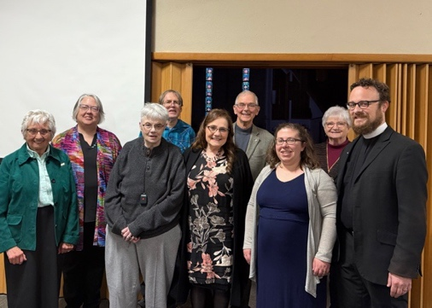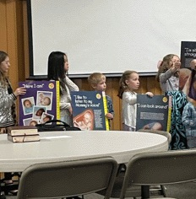

To give the hard-working teachers a break, we viewed the Baby Olivia video and a video depicting the “flash of light” seen at the moment of fertilization that tied in beautifully with the Light of Life theme.
Next Pastor Post connected what the children taught about fetal development with the Annunciation and the conception and development of Jesus in the womb. He had them teach about this by reading Bible passages focusing on our Savior’s work from the very beginning of His life in the womb. Everyone grew in their understanding that the Light of Life started shining well before Christmas!
We then fielded questions like the ones at the beginning of this article. But space is limited so we won’t tell you any of the answers! We praise the Lord of Life for what He accomplished thought His Lil’ Lutherans 4 Life on our Life Sunday.

